
Cloudli Connect Training
How to Create a New Menu Component in Cloudli Connect
Lynn Daviault | 1/5/26 | Cloudli Connect Training

How to Create a New Menu Component in Cloudli Connect
This guide provides a straightforward process for creating a new menu component in the Cloudli platform. By following this guide, users can efficiently configure menu components tailored to their needs, improving their overall telephony management.
- Navigate to https://connect.cloudli.com
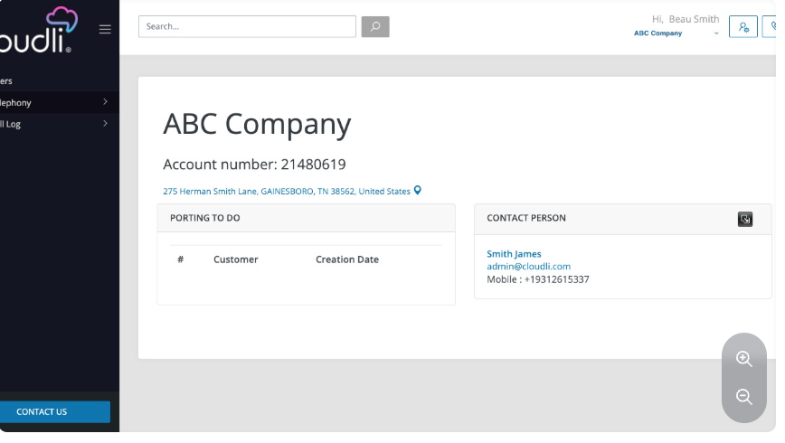
- Click “Telephony”
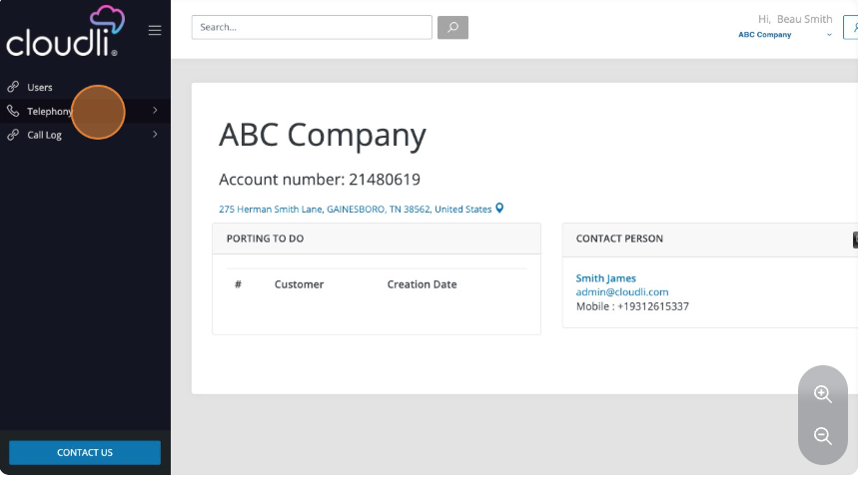

- Click “Menus-Components”.
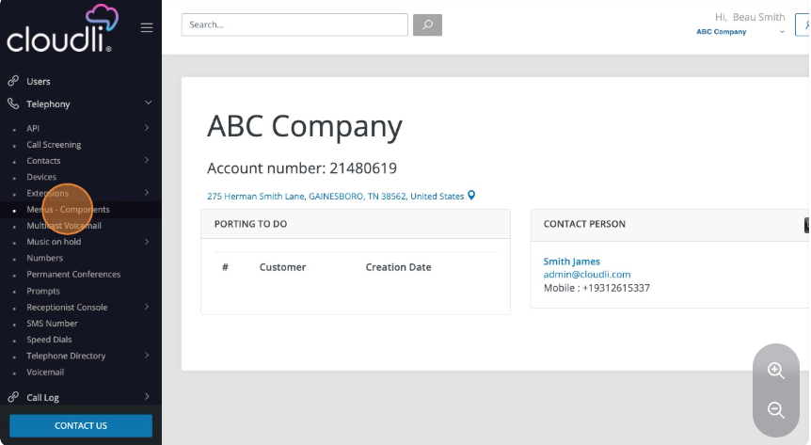
- The main content area will display any previously created menu components; you can click on an existing menu component (if available) to make any edits or updates. To create a new menu component, click "New".
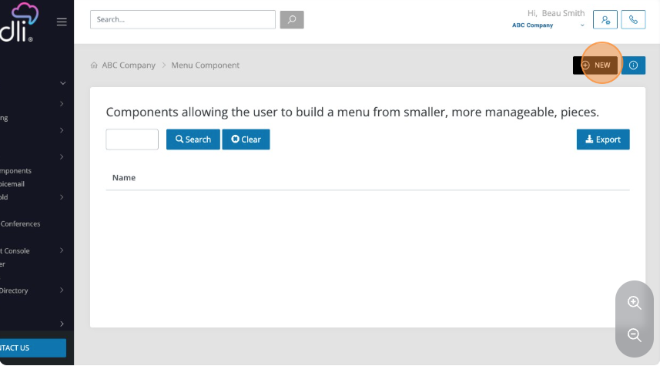

- Enter the name for the menu component
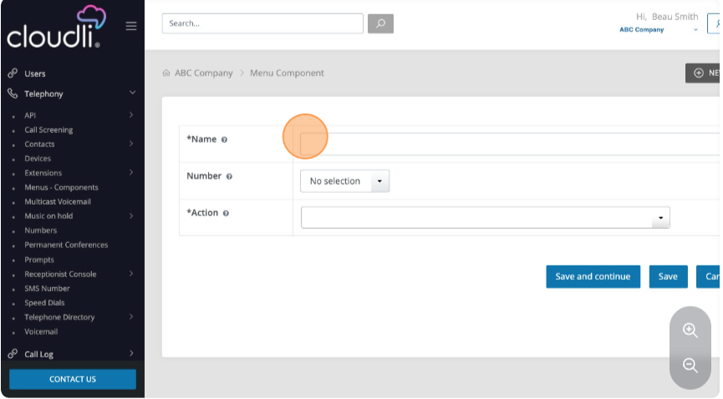
- Select the extension to which you wish to assign the menu component
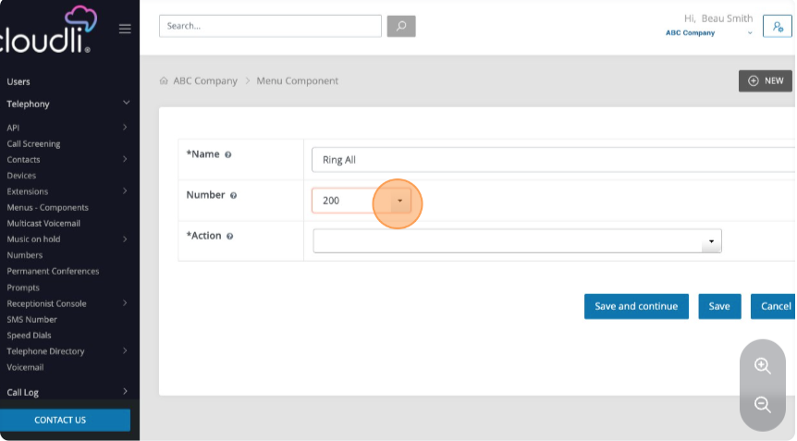

- Select the desired action from the “Action” dropdown menu.
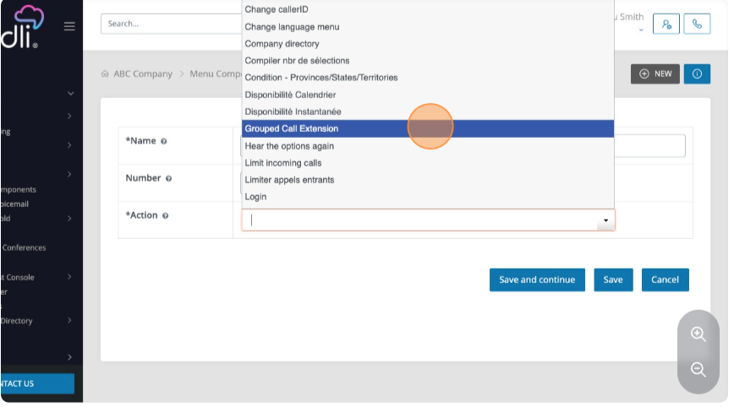
- Additional fields will appear to complete the configuration for the specific action that you have chosen. Please complete all fields.
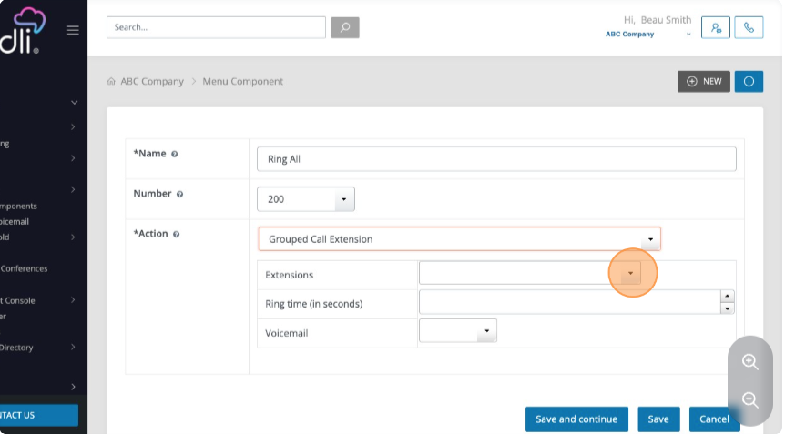

- Once you have completed entering all the required fields, click "Save and Continue." If you have left a field blank, you will receive an error message. If all fields are appropriately populated, you will receive a confirmation message.
